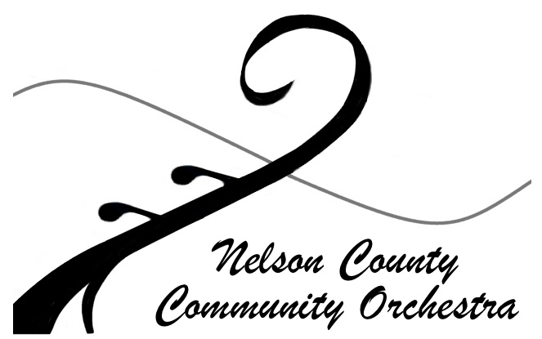

“BRIDGE PROGRAM”
(BP)
GENERAL DESCRIPTION

The Nelson County Community Orchestra (NCCO) continues to grow!! As part of its mission, the NCCO has offered since the fall of 2017, a ‘Bridge Program’, (BP) in Nelson County. Our dream is for everyone in our community to have the opportunity for life-long enrichment by making music part of their lives with hands-on, in-class exposure to orchestral instruments, instruction by professional musicians and opportunities to perform in concerts. The ‘Bridge Program’ “bridges” the gap between beginner students of all ages and the opportunity to play in an orchestra. Once beginners are able to read music and perform at an adequate level, they are invited to join the NCCO.

The BP offers evening orchestral instrument classes for beginner or intermediate level adults, youth and families. Elementary school children will need to be accompanied by their parents. Currently, students are given the option to study their choice of violin, viola, or cello. Instruction in wind instruments and percussion may also be available upon request. Classes are 60-minutes long, in small-groups (2 – 8 students depending on registrations), and held weekly after-school at the Rockfish Presbyterian Church on Monday evenings from 5:30 – 6:30 pm. Private lessons are also available by appointment on Thursday afternoons.

The program is under the instruction of Michael Tyree a highly qualified and experienced teacher. Mr. Tyree is an accomplished violinist, pianist, composer and conductor from Southwest Virginia. He has a Bachelor of Music in Composition from James Madison University and has experience in brass instrumentation. Mr. Tyree is currently the conductor/music director for the Nelson County Community Orchestra and music director of the McGaheysville United Methodist Church Chancel Choir. Mr. Tyree teaches strings and brass in the BP. Additional instructors will be arranged as needed for other orchestral instruments.

The tuition for each weekly class is $20, which includes professional instruction and some materials. Additionally, students need an instrument, a music stand, and the beginner book, all of which are available through the program. Instrument rentals are available for a nominal $10 per month maintenance fee. (Details on the music book and stand are on the registration form.) Members of the Nelson County Community Orchestra are eligible for a discount of $10 for each weekly class.

Music education is a life-long gift. But it is expensive, and often beyond the reach of families. NCCO is committed to providing financial assistance so that all Nelson County Community Orchestra members can participate. Members may request scholarship assistance by contacting the NCCO president or membership coordinator.

Interested students should complete the application for the course and, if needed, the instrument rental application, available on our website: www.nelsoncco.org. For more information, see our website or contact us at info@nelsoncco.org.

‘Bridge Program’
Registration Form

Student’s name ________________________________________________ Date of application: _____________________________
Address: ____________________________________________________________________________________________________
Primary Phone: _______________________________________ Alternate phone: _________________________________________
Which instrument would you like to learn? Violin Viola Cello Other: _______________________________________
Past Musical Activities: Private Lessons _______ Instrument: _________________ Years ______ Teacher _______________________
Please list any other musical activities not included above _____________________________________________________________
____________________________________________________________________________________________________________
Youth students only (elementary age students must be accompanied by an adult):
What school do you attend? ______________________________________ Grade: __________ Age _________ Height: __________
Parents: _____________________________________________ Email Address: ___________________________________________
Emergency contact: In case parents can’t be reached: Name/phone: _____________________________________________________

Class times and date: Classes are held one day per week at the Rockfish Presbyterian Church on Mondays from 5:30 – 6:30 pm following the Nelson County Community Orchestra calendar year (generally late August through the end of May). A summer class may be scheduled based instructor availability. Tuition may be paid monthly or additional monthly increments may be paid in advance.

Cancellations: There are no classes during Thanksgiving week, and during the end of year holiday break. If there is a class cancelation
due to other holidays, weather or instructor illnesses, you will be notified by email. Lessons missed due to holidays, teacher illness or inclement weather will be made up at a time determined by the teacher; other absences will not be made up or credited.

Photographs: You or your child may be photographed during classes or concert performances by NCCO and the image used for NCCO publicity without compensation. You may opt out of allowing NCCO to use your /your child’s image by submitting your request in writing by mail or email to NCCO.

Instrument and Supplies: An instrument, book and folding music stand are required for the class. The SEP program has an inventory of stands and donated instruments that may be rented at very low cost. A folding stand and the appropriate instruction book, Essential Elements, by Michael Allen Violin Book 1 (ISBN # 0634038176), Viola Book 1 (ISBN # 0634038184) or Cello Book 1 (ISBN # 0634038192) may be purchased through the program. Other incidental supplies may be required at the request of the instructor.

Payment and Financial Assistance: NCCO members may request financial assistance by contacting president@nelsoncco.org.
TUITION Non- NCCO member = $20 /class x 4 wks = $80/mo X ____ months = $ _________
or
NCCO Member = $10 /class x 4 wks = $40/mo X ____ months = $ _________
INSTRUMENT RENTAL = $10 per month (optional, ongoing fee) = $ _________
BOOK PURCHASE = $10 (optional, one time fee) = $ _________
STAND PURCHASE = $15 (optional, one time fee) = $ _________ TOTAL $__________
All Tuition Payments are due to the NCCO PO Box by Monday of the first week of the each month.

Checks should be made payable to NCCO: Submit this form, along with full payment for class fee, instrument, stand and instruction book to NCCO-SEP, Treasurer, PO Box 295, Nellysford, VA 22958, or treasurer@nelsoncco.org. Be sure to note “Bridge Program” in the reference line of all checks. If you have questions, please visit our website, www.nelsoncco.org, call 434-263-4745 or email info@nelsoncco.org.

